Parameters can function as input, output and throughput.

Input, Output, Throughput
Bij een functie AANROEP, bij de parameters moeten aangeven of het in out of thru.
Dit voor de duildeijkheid, dat er een waarde terug komt of er doorheen gaat

Figure out the ins and outs of reference argument vs. real argument.

<
The only thing this doesn’t match yet is: how to express:

- in / out / through / local
- access to privates / access to publics
- optional / required

Especially expressing the distiction between access to privates / access to publics is what I am most concerned about.
But what I have done here in this brainstorm, is solve the main problem. I have, however, broadened the scope already.
>
Parameters, including the object the method ‘would be called upon’, have different functions, which may affect the way they will be displayed in the diagram:

- in / out / through / local
- access to privates / access to publics
- optional / required

This alters the object’s position in relation to to the method.

For now I will only consider input parameters.

First I consider one required input parameter to which the method has private access. A call to this method will translate to a call to the object.

< You could find rules, that determine which of the parameters might be most important. And make that the object called upon. But those rules could result in a tie. In that case there must be a way to express you are calling a method on both objects, but that should not be an expression of calling a method, that just references both objects. >

< If you stereotype something as in / out / through / access to privates or just publics or optional or required, it does set certain bounds to the parameters, but doesn’t guarantee the argument is actually used that way. You could define a parameter as throughput, but actually only read from it. In that case the parameter should implicitly be degraded to an input parameter. The class could declare a parameter as access to privates, but the method may only access the public contents. In that case the parameter type is implicitly considered access to only publics. So the implicit parameter type is dependant on the way it is declared and the way it is used. From now on, when I speak of a parameter type, I will be talking about the implicit parameter type. Meaning: an throughput parameter is not only declared as such, but also always used as such. >

<
Throughput could have the following elements:
- affected
- used
- transformed
Affected means that what’s written to the object is not dependant on the original contents of the object.
Affected and used means the same as affected, but also values are read from the object, but the read values do not have an effect on the object itself.
Transformed means that what’s written to the object is dependant on what was first read from the object.

< Actually, just affected is not throughput at all, that’s output. >

>

< I shall consider the following forms as well:

- One required input parameter with private access
Two required input parameters with public access only
- One required input parameter with private access
One required input parameters with public access only
One local variable with private access
- One local variable with public access
- I just don’t know yet
>

<

- input
input is not an object that something is done to. It can be considered an object doing something to another object. So it is clearly an actor.
The input parameter always needs to affect something else, but can’t affect itself, or it will be characterized as transformed throughput.
It can be an object called upon.
- output
An output parameter can never be considered an object called upon, because the output parameter only exists after the call, not before.
- affected throughput
A throughput affected parameter can be considered a call to the object, but requires the method to have other parameters as well, that are input or used throughput, that are applied to the affected throughput parameter.
- used throughput
- transformed throughput
- local
the object only exists when the method runs.
In other programming languages a local variable can point to something existing, but in the new computer language, that will be considered input or output of the method.
- access to privates
- access to publics
- optional
- required

>

<
I think you could break it down to even more basic characteristics:

- used to affect another ( = input )
- used to affect itself ( = throughput )
- affected by another ( = ~ output / affected
- produced ( = output )
- temporarily existant

- privates used to affect another
- privates used to affect itself
- privates affected by another
- always used / affected / produced
- not always used / affected / produced

- However, when something is temporarily existant, it might in its temporary existance be affected and used. But then the temporary existant object is passed along to another method as a parameter. The object has a different relation with the other method.

- one time a method runs, something may only be read. Another time it may be read and written to. This changes the implicit position of the object in relation to to the method in each call to the method.

- The thing is: you can both see a method as part of the thing affected, and the method can also be part of the thing that affects something else.

- Always something is the input and something is the output: at least one thing is used, and at least one thing is affected. But the affected thing can also be a new thing
One thing is executed on another. So its data executed on data.
< ~ The method is considered part of both input and output, so it is always considered part of multiple objects. >
When something is output, so didn’t exist yet before, the method can also be a static part of the class, because now there wasn’t an object to begin with, but the method still has something to do with the class.

>
< It matters whether the object is used (read), affected (written), or produced. This alters the object’s position in relation to to the method. >

< A local variable may make the method a static method of a class, instead of a method of an object. >

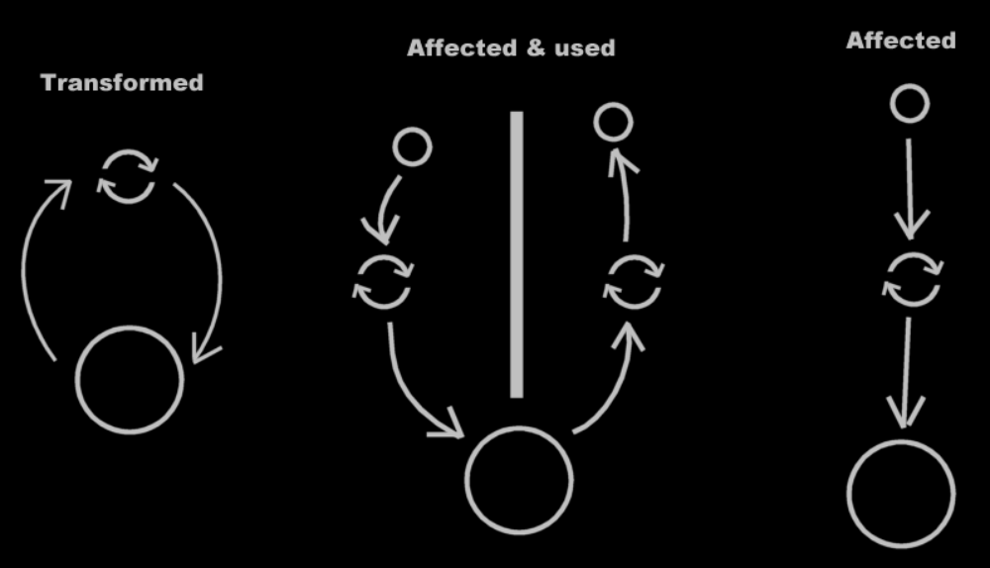

Remember: any piece of data used by a method is a parameter of the method.
If a sub object of a parameter is used, this data is considered a parameter itself, because it gets read or is affected.
The usage of the data is analysable in the new computer language, and the usage of the data is important, and determines the data’s position in relation to the method.

That is actually only true from an input / output / throughput perspective: what data is used, adapted, or used and adapted.
From a method part of class perspective it is not so that any piece of data is a parameter of the method.

